Student Worksheet
Name: Varun thakur Roll No.:GF202567457 Partner (if any): __________________
How this hour works
You will build a small deliverable using a free ChatGPT account, one step at a time. Keep everything in the same chat thread unless a step says to start a new one. Write your prompts and findings in the boxes as you go — that is what gets collected at the end.

Reference: what goes into a good prompt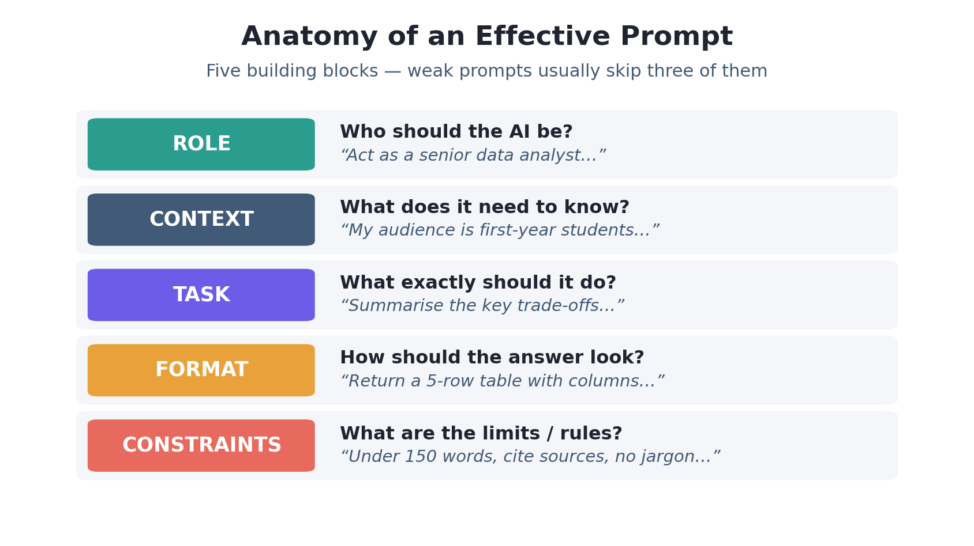

Part 1 · Vague vs. engineered (10 min)
Goal: see how much the wording of your request changes the answer.

Step 1 — Send a lazy prompt
Type this exactly and read the reply: “tell me about databases”
Ans --- The answer was too broad and generic—it explained databases at a basic level but didn’t provide enough depth, practical examples, or a clear learning path.

Step 2 — Rewrite it using the five building blocks
Fill each blank, then send your rewritten prompt in the same chat:
Role: “Act as senior database engineer and computer science tutor …”
Context: "I am a first-year student and I want to understand databases before I start learning backend web development, since I have no prior experience with how data is stored or organized.”
Task: “Explain learning backend web development (like Node.js and Express), but I have zero prior experience working with data storage..._ …”
Format: "Give the answer as a clear comparative table, followed by one simple real-world example... (e.g. a 5-row table)."
Constraints: “Keep it under 300 words and avoid advanced jargon.
The Task building block made the biggest difference because it clearly specified what to explain and tailored the answer to a first-year student with no prior database experience.

Part 2 · Iterate to a draft (12 min)
Goal: improve an answer by steering, not restarting. Pick ONE mini-task below (or your own):
- Draft a 5-day revision plan for an upcoming exam.
- Write a short, friendly email asking a professor for a deadline extension.
- Explain a topic from another course to a 12-year-old.
Send your first prompt, then send three follow-ups — do NOT delete the thread. Record what you asked each time:
Turn | Your follow-up prompt | What changed in the answer
1 | Make the revision plan shorter and easier to follow. | The plan became more concise, with fewer tasks each day.
2 | Add a real example of what I should study each day. | Specific subjects/topics and study activities were added for each day.
3 |  | The final answer was organized into a table with daily topics, study tasks, and break times.
  Now put the plan in a clear table and include breaks.

Try these steering phrases
“shorter” · “add a real example” · “now as a table” · “too formal — make it friendlier” · “explain the second point more” · “give me 3 options”

• “Make the revision plan shorter and easier to follow.”
• “Add a real example of what I should study each day.”
• “Now put the plan in a clear table and include breaks.”

Part 3 · ChatGPT as a data analyst (11 min)
Goal: hand raw data to the AI and get a summary, a table, and a chart back — then check it.

Step 1 — Give it the data
Best option: save the dataset below as a .csv file and upload it. If upload is unavailable on your account today, just paste the text straight into the chat — it works the same way.
+--
Sample dataset — copy this in
Month, Users, Revenue_INR
Jan, 120, 24000
Feb, 150, 30500
Mar, 145, 29800
Apr, 190, 41000
May, 240, 52500
Jun, 300, 66000

Step 2 — Ask for analysis
Send: “Here is 6 months of data. Summarise the trend in 3 bullet points, show a table with a month-over-month growth column, and create a line chart of Users over time.”
Write the main trend ChatGPT reported: Trend summary
- Users increased strongly, from 120 in January to 300 in June — a 150% overall increase.
- Revenue also increased consistently overall, from ₹24,000 to ₹66,000, with a small dip in March.
- The strongest month-over-month user growth was in April (+31.0%).
Month-over-month growth
Month | Users | Revenue (₹) | User MoM Growth
Jan | 120 | 24,000 | —
Feb | 150 | 30,500 | +25.0%
Mar | 145 | 29,800 | -3.3%
Apr | 190 | 41,000 | +31.0%
May | 240 | 52,500 | +26.3%
Jun | 300 | 66,000 | +25.0%
Users over time
Users over time
Monthly user growth from January to June.
65130195260325JanFebMarAprMayJun

Step 3 — Sanity-check it
Add up Revenue_INR yourself. Does the total ChatGPT gives match? Never trust a number you have not spot-checked.
Your total: ₹243,800 ChatGPT’s total: ₹243,800 Match? Y

Part 4 · Catch the error (10 min)
Goal: prove to yourself that a confident answer can still be wrong. This is the single most important habit with any AI tool.
- Ask for something specific and checkable, e.g. “List 3 published research papers on <your topic>, with authors, year, and a working link.”
- Now verify ONE of them: search the title. Does the paper actually exist, with those authors and that year?

- Now verify ONE of them: search the title. Does the paper actually exist, with those authors and that year?
- Try a second trap: ask it to multiply two awkward numbers, e.g. 68,391 × 27. Check with a calculator.

Describe one thing ChatGPT got wrong or “made up,” and how you caught it:
I got an answer from ChatGPT. I asked it to multiply 68,391 by 27. Then I used a calculator to check the result. The calculator said the right answer was 1,846,557. That was not the same, as what ChatGPT gave me. This made me realize that I should always check numbers instead of believing a confident AI response.

The rule to remember
AI output is a fast first draft, not a source of truth. Anything factual, numerical, or cited must be verified before you use it.

Part 5 · Reflect & debrief (7 min)
One prompt pattern I will actually reuse after today:

One task I would trust AI with — and one I would NOT:

Bonus (if you finish early)
Paste ChatGPT’s own answer from Part 2 back to it and ask: “Critique this answer as a strict teacher and rewrite it better.” Notice that it can improve its own work when told how.

One prompt pattern I will actually reuse after today:

“Act, as [role]. I need [task] for [audience]. Give it as [format] under [N] words.”

One task I would trust AI with. And one I would NOT:

I would trust AI to help me summarize information and create study plans. I would NOT trust AI blindly with facts or decisions without verifying the information.

Keep this · Prompt patterns cheat-sheet
When you want… | Say something like
A useful answer, first try | “Act as [role]. I need [task] for [audience]. Give it as [format], under [N] words.”
A shorter / simpler answer | “Summarise in 3 bullets.” · “Explain like I’m 12.”
A different shape | “Put that in a table.” · “Turn it into a checklist.”
More depth on one part | “Expand point 2 with an example.”
To trust a fact | “Give sources I can verify.” — then actually check them.
Options, not one answer | “Give me 3 different approaches with trade-offs.”

Learning AI Tools · Prompt to Product Lab · One free ChatGPT account, one hour, one transferable skill.

